International Alliance for Cancer Early Detection (ACED)

Manchester ACED PhD Studentship 2026
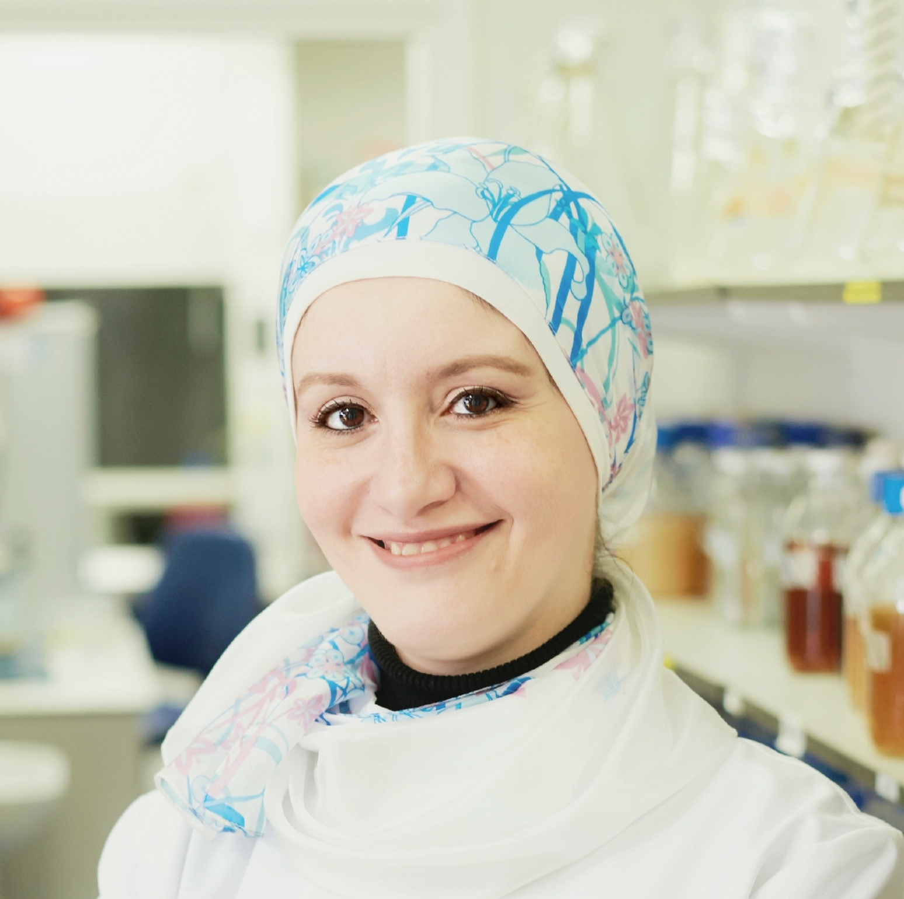 | Dr Mahetab Amer  Division of Cell Matrix Biology & Regenerative Medicine  Contact Information:  Email: mahetab.amer@manchester.ac.uk  Website: https://research.manchester.ac.uk/en/persons/mahetab-amer  Research Area of Interest:  My research focuses on engineering 3D microenvironments to study how physical cues in the bone niche regulate cell behaviour and may enable tumour cell colonisation and metastasis. By identifying early biophysical changes, we aim to develop model systems that support earlier detection and understanding of bone metastasis and primary bone tumours.  Proposed Research Question:  How do bone-relevant topographical cues influence the early stages of breast cancer cell proliferation and dormancy in the bone niche, and can these mechanobiological interactions be harnessed to develop biomaterial-based platforms for early detection of metastasis?
 | Professor Susan Astley Theodossiadis  Division of Informatics, Imaging & Data Sciences  Contact Information:  Email: sue.astley@manchester.ac.uk  Website: https://research.manchester.ac.uk/en/persons/susan-astley-theodossiadis  Research Area of Interest:  I'm interested in the early detection of breast cancer, and particularly in the use of AI to assist the process.  Proposed Research Question:  Does explainable AI actually provide useful clinical information? Does it have the potential to improve the decisions of clinical experts, or might it be confusing or distracting?
 | Dr Andrew Gilmore  Division of Cancer Sciences  Contact Information:  Email: andrew.gilmore@manchester.ac.uk  Research Area of Interest:  Breast cancer is the leading cause of mortality in women between 35-64 years. A significant issue is detecting breast cancer in women below the start of population screening age. We want to identify young women at high risk and develop approaches to detect cancer in them earlier.  Proposed Research Question:  Can we identify biomarkers within high risk breast tissue that can be developed to detect hard to treat tumors
 | PhD, Group Leader, Head of Cancer Immunosurveillance Group Evangelos Giampazolias  Cancer Immunosurveillance Group, Cancer Research UK Manchester Institute  Contact Information:  Email: evangelos.giampazolias@cruk.manchester.ac.uk  Website: https://www.cruk.manchester.ac.uk/team-member/evangelos-giampazolias/  Research Area of Interest:  We investigate how diet, the gut microbiome, and the immune system interact to influence cancer development and treatment response. Our work revealed that microbiota-driven cancer immunity critically depends on vitamin D availability. We aim to identify microbial functions predictive of cancer onset, immunotherapy outcomes and targetable to overcome therapy resistance.  Proposed Research Question:  How do dietary factors such as vitamin D shape the gut microbiota to influence immune surveillance and cancer development? Using carcinogen-induced mouse cancer models and human biospecimens, we will track microbiota changes during tumour progression and identify alterations that serve as early biomarkers for cancer detection and therapy response.
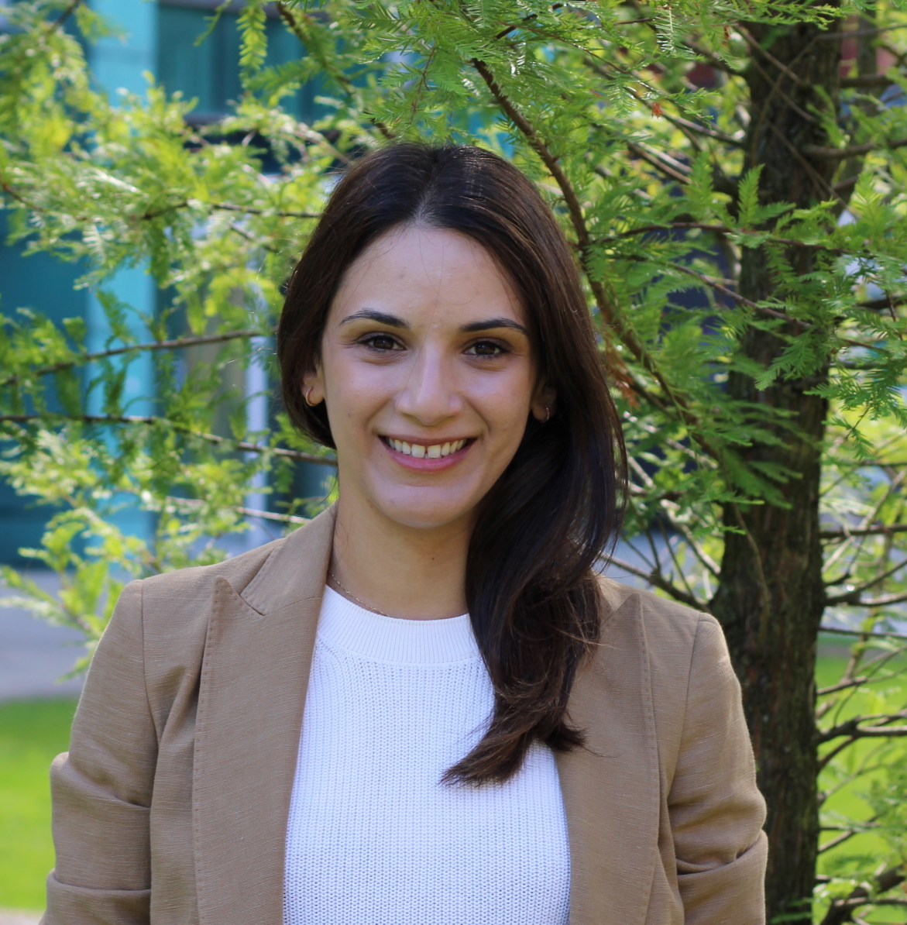 | Dr Marilena Hadjidemetriou  Centre of Nanotechnology in Medicine, Division of Cancer Sciences  Contact Information:  Email: marilena.hadjidemetriou@manchester.ac.uk  Website: https://cnanotechmed.com/  Research Area of Interest:  My lab develops nanotechnology-enabled liquid-biopsy platforms to uncover novel blood biomarkers for early detection, while unravelling the underlying biological processes.  Proposed Research Question:  Can nanoparticles enable multi-omics enrichment analysis of cancer clinical samples?
 | Professor Petra Hamerlik  Division of Cancer Sciences  Contact Information:  Email: petra.hamerlik@manchester.ac.uk  Research Area of Interest:  As Chair of Translational Neuro-Oncology, my research focuses on the development of non-invasive liquid biopsy approaches for the early detection of primary and secondary brain tumours. I lead several translational projects exploring the diagnostic potential of biofluids such as plasma, tears, and saliva. These studies aim to identify tumour-derived biomarkers that can be detected through minimally invasive means, enabling earlier diagnosis, improved monitoring, and more personalised treatment strategies for patients with brain cancer.  Proposed Research Question:  Can non-invasive liquid biopsies from saliva enable reliable early detection and monitoring of paediatric brain tumours through identification of tumour-derived molecular biomarkers?
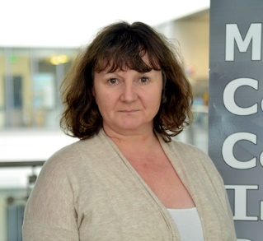 |  | Professor Tracy Hussell  Lydia Becker Institute of Immunology and Inflammation  Contact Information:  Email: tracy.hussell@manchester.ac.uk  Website: https://research.manchester.ac.uk/en/persons/tracy.hussell  Research Area of Interest:  In a collaboration between the UoM and the Christie Hospital, we have defined proteomic signatures that detect early lung cancer, and now will extend this to head and neck cancers  Proposed Research Question:  Defining a saliva proteomic signature for the early detection of head and neck cancer. Using an established bank of pre-and post-operative samples through to cancer recurrence, we will define signals that indicate the need for surgical or therapeutic intervention.
 |  | Senior Group Leader Claus Jorgensen  Cancer Research UK Manchester Institute  Contact Information:  Email: claus.jorgensen@cruk.manchester.ac.uk  Website: https://www.cruk.manchester.ac.uk/team-member/claus-jorgensen/  Research Area of Interest:  Pancreatic precancer lesions are common and only a minority will progress. To avoid overdiagnosis it is critical to determine how progression is regulated to distinguish malignant from indolent precancers. The microenvironment can regulate tumour development, and we are interested in identifying the signals that drive or inhibit progression.  Proposed Research Question:  We are interested in identifying signals from the evolving microenvironment that promote or inhibit the development of Pancreatic Cancer. Using human samples, proteomics and novel 3D in vitro models, we wish to interrogate changes in the extracellular matrix and tissue stiffening to reveal novel principles of malignant progression.
 |  | Dr Sean Knight  Division of Immunology, Immunity to Infection and Respiratory Medicine  Contact Information:  Email: sean.knight@manchester.ac.uk  Website: https://research.manchester.ac.uk/en/persons/sean.knight  Research Area of Interest:  My lab is focussed on understanding how immune cells react when they encounter an emerging tumour for the first time. We are looking for products of these encounters that can be harnessed as early detection tests.  Proposed Research Question:  How does the immune system permit early cancer growth?

 | Dr Lorna McWilliams  Manchester Centre for Health Psychology, Division of Psychology & Mental Health  Contact Information:  Email: lorna.mcwilliams@manchester.ac.uk  Website: https://research.manchester.ac.uk/en/persons/lorna.mcwilliams  Research Area of Interest:  As a behavioural scientist, my research interests focus on behaviour change, implementation science and healthcare decision-making within cancer early detection and risk communication. My research aims to improve health equity for example, how having severe mental illness or an intellectual disability affects lung cancer risk perceptions, screening decision-making and outcomes.  Proposed Research Question:  How can behaviour change and implementation science theory be applied to improve equitable lung cancer risk communication, screening decision-making, and early detection outcomes among underserved populations, including individuals with severe mental illness or intellectual disabilities?
 | Dr Sam Merriel  Centre for Primary Care & Health Services Research  Contact Information:  Email: samuel.merrel@manchester.ac.uk  Website: https://research.manchester.ac.uk/en/persons/samuel.merriel  Research Area of Interest:  Early detection and prevention of cancer in primary care settings. Developing and evaluating new cancer diagnostic tests for primary care. Inequalities in cancer early detection.  Proposed Research Question:  What are the most effective primary care and community interventions for reducing inequalities in early cancer detection?
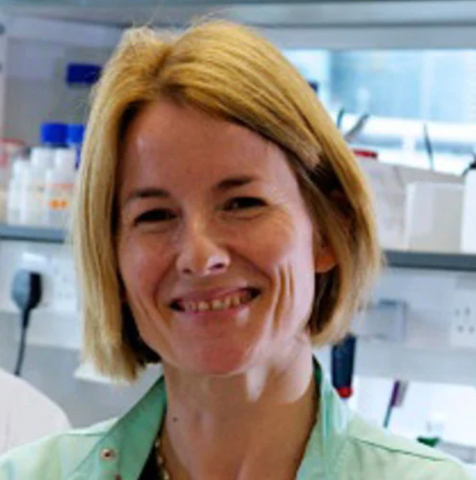 | Professor Karen Piper Hanley  Division of Diabetes, Endocrinology & Gastroenterology  Contact Information:  Email: karen.piperhanley@manchester.ac.uk  Website: https://research.manchester.ac.uk/en/persons/karen.piperhanley  Research Area of Interest:  My research focuses on understanding how changing cell states and tissue ecosystems in chronic liver disease contribute to progression toward hepatocellular carcinoma (HCC). Using single-cell and spatial multi-omics, we aim to define early molecular changes and biomarkers that distinguish indolent from high-risk disease, with the goal of informing translational diagnostics for early cancer detection.  Proposed Research Question:  How do altered regenerative responses and cell state transitions in hepatocytes during chronic liver disease contribute to immune escape and early transformation into hepatocellular carcinoma, and can single-cell and spatial multi-omics reveal biomarkers that distinguish high-risk lesions for earlier detection and stratification?

 | Dr Christine Schmidt  Division of Cancer Sciences  Contact Information:  Email: christine.schmidt@manchester.ac.uk  Website: https://research.manchester.ac.uk/en/persons/christine.schmidt  Research Area of Interest:  We study the molecular landscape of pre-invasive ovarian cancer lesions in the fallopian tube using omics approaches in different model systems, aiming to identify early detection markers. We also develop engineered microrobots as lesion-specific sensors that can further enable curative interventions at the earliest stages of disease.  Proposed Research Question:  Can we harness the unique window of opportunity when pre-invasive ovarian cancer lesions arise in the fallopian tube to enable early detection - by developing minimally invasive methods, such as falloposcopy, to deliver sensor platforms like engineered microrobots that can detect lesions before they spread and become incurable?
 | Dr Stuart Wright  Manchester Centre for Health Economics  Contact Information:  Email: stuart.j.wright@manchester.ac.uk  Website: https://research.manchester.ac.uk/en/persons/stuart.j.wright  Research Area of Interest:  My work revolves around building computer models of cancer screening programmes to explore how changes to programmes will impact on clinical and cost outcomes for patients. I am also interested in understanding preferences for cancer screening  Proposed Research Question:  How can the natural history of ductal carcinoma in situ be better modelled to improve predictions from a model of breast cancer screening?
 | Prof Robert Bristow  Manchester Cancer Research Centre  Contact Information:  Email: Robert.bristow@manchester.ac.uk  Website: https://research.manchester.ac.uk/en/persons/robbie-bristow  Research Area of Interest:  We wish to understand how somatic mutations and the TME (e.g. cancer immunology and metabolism) direct tumour cell evolution in hereditary (e.g. germline mutations in BRCA2 or ATM genes), and sporadic prostate cancers. We create new models and conduct multi’omic analyses (WGS and spatial transcriptomics/proteomics) directly from patient samples.  Proposed Research Question:  In ovarian and breast cancer, germline BRCA1 and BRCA2 mutations both drive cancer risk and progression. So why do only germline BRCA2 mutations, and not BRCA1 mutations, drive carcinogenesis and progression in prostate cancer ? Can we model this differential “BRCA tumour cell evolution” in vitro and in vivo?

 | Prof Samra Turajlić  Cancer Research UK Manchester Institute  Contact Information:  Email: samra.turajlic@cruk.manchester.ac.uk  Website: https://www.cruk.manchester.ac.uk/research-group/cancer-dynamics/  Research Area of Interest:  One of the greatest challenges in cancer medicine is understanding and predicting the trajectory of individual cancers. My lab uses methods from evolutionary biology to understand the variable natural history of individual cancers, and most critically the emergence of metastases and drug resistance. We apply evolutionary principles to address the question by studying the forces that shape cancer evolution and use this knowledge to improve patient outcomes.  Proposed Research Question:  Can we test the hypothesis that baseline tissue metabolism impacts immune surveillance before cancer becomes clinically detectable? Can we identify measurable metabolic-immune biomarkers predictive of early cancer risk? Finally, can we establish a mechanistic basis for metabolically targeted cancer interception?

