ACED acknowledgement summary for researchers

Publication acknowledgements

Any paper or poster being submitted relating to work funded through the MERCADO (ACED Infrastructure award) or ACED award please ensure that you use the following wording to acknowledge the funding source:

This work was supported by CRUK via the funding to ACED [C19941/A29320]

- If ACED pilot / project / skills exchange substitute the code from your award letter
- If ACED PhD student substitute [C19941/A27859]

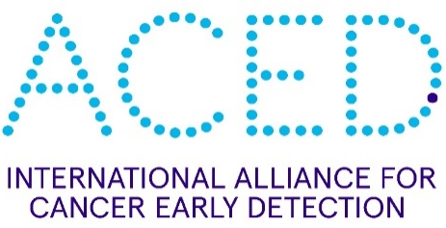
An ACED Logo also needs to be included:
OR

Our relationship with CRUK continues to be very important and we need to ensure we appropriately acknowledge where CRUK is placing its monies around the UK.

Contact the Manchester ACED Programme Manager (E: Martin.Bone@manchester.ac.uk) if you have any questions or would like to receive the ACED Communication Toolkit.

